 | EXPLANATION | EXAMPLE
LEVIS-STRAUSS' BINARY OPPOSITIONS | Narratives are based on CONFLICT. No conflict, no story. | Heroes need opposition. Heroes need villains.  Most important in a story; without opposition, characters have no personality.
TODOROV’S THEORY | Narratives have THREE STAGES called equilibrium, disequilibrium, (recognition – realization), new equilibrium. That means everything starts well, then goes wrong, then is sorted out somehow. | Guardians of the Galaxy;  - Equilibrium: everyone is normal; Starlord is an adventurer, steals stuff  - Disequilibrium: Starlord is caught and meets other Guardians of the Galaxy  - New equilibrium: main character solves problem, desires fulfilled
BARTHE’S HERMENETIC (ENIGMA) CODE | Narratives are based on MYSTERY. We are always waiting to find the answer to some question. | Guardians of the Galaxy: Starlord is always listening to a 70s song on a Walkman and gets very angry when it is taken – why?
PROPP’S THEORY | There are CHARACTER TYPES (called ‘archetypes.’) A character might be a hero, or a villain, or a leader. (There are seven possibilities.) Once we know what they are, we know what they’re going to do. (A hero, for example, will always do ‘the right thing.’) Thus, we pretty much know how the story will go. | 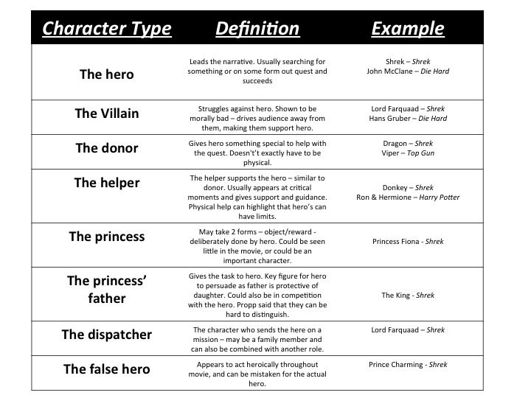

There is always one main character.

